Database Resource

📝Definition
# Source: AI Source: Provided by: [Data Path: Persons Table -> ID Column: 1, Name_En Column: Motasem Essam] -> From: [ChatGPT] on [1/23/2026]
A Database Resource is any persistent data storage your application relies on to store, retrieve, and manage information. It provides a structured and reliable way for the system to access core business data.
Think of it as the source of truth for your application’s information.

🔑 Key Points
# Source: AI Source: Provided by: [Data Path: Persons Table -> ID Column: 1, Name_En Column: Motasem Essam] -> From: [ChatGPT] on [1/23/2026]
- Stores structured or unstructured data (tables, collections, documents)
- Can be relational (SQL) or non-relational (NoSQL)
- Accessed via ORMs, repositories, or queries
- Often used in combination with Services and Models to keep code modular

🧱 Examples

1️⃣ Relational Database (SQL)
# Source: AI Source: Provided by: [Data Path: Persons Table -> ID Column: 1, Name_En Column: Motasem Essam] -> From: [ChatGPT] on [1/23/2026]
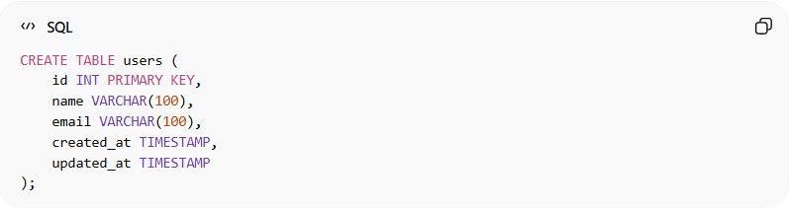
CREATE TABLE users (
id INT PRIMARY KEY,
name VARCHAR(100),
email VARCHAR(100),
created_at TIMESTAMP,
updated_at TIMESTAMP
);
- users table is a database resource
- Controllers, services, and repositories fetch data from it

2️⃣ NoSQL Database (MongoDB)
# Source: AI Source: Provided by: [Data Path: Persons Table -> ID Column: 1, Name_En Column: Motasem Essam] -> From: [ChatGPT] on [1/23/2026]
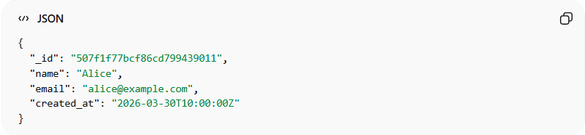
{
"_id": "507f1f77bcf86cd799439011",
"name": "Alice",
"email": "alice@example.com",
"created_at": "2026-03-30T10:00:00Z"
}
- A collection of documents is a database resource
- Can be queried and updated via database drivers or ORMs

3️⃣ Laravel Example
# Source: AI Source: Provided by: [Data Path: Persons Table -> ID Column: 1, Name_En Column: Motasem Essam] -> From: [ChatGPT] on [1/23/2026]
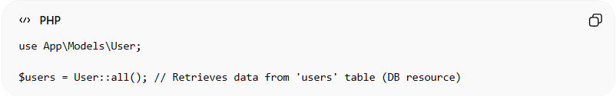
use App\Models\User;

$users = User::all(); // Retrieves data from 'users' table (DB resource)
- The users table is the database resource
- User model acts as a representation of the DB resource

❌ Bad Example
# Source: AI Source: Provided by: [Data Path: Persons Table -> ID Column: 1, Name_En Column: Motasem Essam] -> From: [ChatGPT] on [1/23/2026]
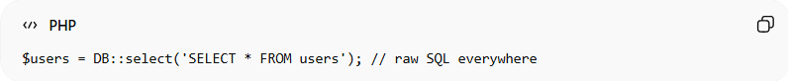
$users = DB::select('SELECT * FROM users'); // raw SQL everywhere
Problems:
- Hard to maintain queries
- Breaks separation of concerns
- Hard to test or reuse

✅ Good Example
# Source: AI Source: Provided by: [Data Path: Persons Table -> ID Column: 1, Name_En Column: Motasem Essam] -> From: [ChatGPT] on [1/23/2026]
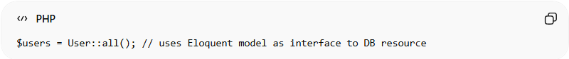
$users = User::all(); // uses Eloquent model as interface to DB resource
- Centralizes data access in models/repositories
- Keeps controllers/services clean
- Easier to maintain, test, and refactor

💡 Summary:
# Source: AI Source: Provided by: [Data Path: Persons Table -> ID Column: 1, Name_En Column: Motasem Essam] -> From: [ChatGPT] on [1/23/2026]
A Database Resource is the persistent data layer of your application, providing reliable access to core business information while remaining modular and maintainable through models, repositories, or services.

